
Arizona State University
IRB FAQs
Revised April 30, 2025
Contents
General Inquiries 4
How do I know if my proposed project requires ASU IRB approval? 4
Are there any special requirements if ASU is serving as a study site? 4
Who can serve as the Principal Investigator (PI) on an IRB submission? 4
What resources are available to review Federal regulations and ASU policies? 5
Enterprise Research Administration (ERA) System 5
What is ERA and how do I access the portal? 5
I am trying to login to ERA, but I am receiving an error message. Who should I contact for assistance? 5
What are the different submission states in ERA? 5
Where should I upload my documents for review of my submission in ERA? 5
Why hasn’t my submission been reviewed in ERA yet? 6
I left a comment on my submission, why hasn’t the IRB Coordinator responded? 7
CITI Training 8
Who is required to complete human subjects research training and how can I access it? 8
How do I know which CITI course I need to take? 8
I completed a Responsible Conduct of Research (RCR) course. Does this count towards the IRB CITI course training requirement? 8
I am transferring from another university. Does ASU accept certificates from other institutions? 8
How do I login to CITI and start my IRB training? 9
I can’t find the IRB CITI training course from the instructions above. Once I add a CITI course, what do I do next? 9
Does my CITI training expire? 9
How many times can I take the IRB CITI refresher course before I need to retake the main course? 9
I tried to take the IRB CITI refresher course, but it wasn’t available even though I still had another refresher attempt. 10
Application Process 10
My sponsor requires IRB approval before my grant can be accepted. What documentation can I provide since my study plans are not finalized yet? 10
What is the Wizard Tool and how do I know if my study is eligible? 10
My study is not eligible for the Wizard Tool. How does the ASU IRB review applications? 11
I would like to submit my study for IRB review. What materials do I need to prepare before submitting my application to ERA? 11
As I am gathering my application materials, what are some examples of special circumstances I should consider? 12
A. Data Use Agreements (DUAs) 12
B. Research Subject Compensation 12
C. Collaborating with Other Institutions 13
I have all my materials ready to go. How do I submit my study through ERA? 14
Study Modifications 15
How would I add or remove members from the study team? 15
How would I make changes to my approved IRB protocol? 15
I received a grant for my IRB study. How do I add the funding to my approved IRB study? 15
I would like to change the PI of my approved IRB study. How do I transfer the study over to the new PI? 16
Reportable New Information 16
What is Reportable New Information (RNI)? 16
When must adverse events be reported? 16
How do I submit a RNI for review? 17
Continuing Reviews 17
What is a Continuing Review? 17
Is there a template for the progress report? 17
How to I submit a Continuing Review in ERA? 18
Study Closure 18
Our team has completed all human subjects research activities. We are now in the process of publishing our results. Do I need to submit a Continuing Review? 18
The activities for this project are complete. How do I close my study in ERA? 18
If my study is closed, am I able to reopen my study for additional project scope? 19

General Inquiries

How do I know if my proposed project requires ASU IRB approval?
IRB review is required if the study meets the definition of involving human subjects and the definition of research.
- A human subject is defined as “a living individual about whom an investigator conducting research obtains data through intervention or interaction with the individual or identifiable private information.”

- Research is defined as “a systematic investigation, including research development, testing and evaluation, designed to develop or contribute to generalizable knowledge.”

This includes conducting research using online surveys, analyzing human subject data that have been previously collected, analysis of coursework, interviews, etc.

If you are unsure if IRB review is required, please contact ASUIRB@asu.edu.

Are there any special requirements if ASU is serving as a study site?
If ASU is serving as a study site and no ASU students, faculty, staff, or employees will be members of the research team (or will be collaborating with external research team outside ASU besides being subjects of the research/research participants), then formal review by the ASU IRB is not required.

Note that the ASU IRB cannot provide access to the study sample. You may be required to contact the appropriate department/unit for approvals. For more information about the review process (and appropriate contact), you may review the form below:

Lastly, note that this process is also applicable to ASU investigators collecting data from ASU students, faculty, and/or staff outside of the PI’s department/college/unit.

Who can serve as the Principal Investigator (PI) on an IRB submission?
Only full-time faculty/staff (i.e., not students or postdocs) can serve as the PI on the IRB submission. See policy regarding PI Eligibility.

What resources are available to review Federal regulations and ASU policies?
Investigators can review Federal regulations, Federal guidance documents, ethical codes, and ASU and ABOR policies and procedures related to Human Subjects Research here: Regulations and Resources.

Enterprise Research Administration (ERA) System

What is ERA and how do I access the portal?
ASU's Enterprise Research Administration system (ERA) provides an integrated platform for the administration of research and sponsored projects at ASU. ASU Researchers use this portal to submit IRB application materials for review.

You can access the system here: ERA Portal.

I am trying to login to ERA, but I am receiving an error message. Who should I contact for assistance?
- ASU Employees (Faculty, Staff and Student Workers):
Submit access and role requests or report login issues through ServiceNow ERA Account Support.
- ASU Affiliates (Students, Emeritus or Adjunct Faculty, and Other Affiliates):
Affiliates not employed by ASU use the ASU Affiliate Account Support Form.

What are the different submission states in ERA?
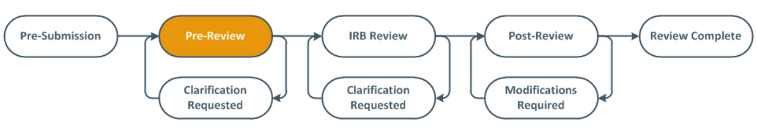
You can learn more about these submission states via the links below:
- Review Process
- Review Process Video

Where should I upload my documents for review of my submission in ERA?
The IRB protocol should be uploaded under “Basic Study Information – Attach the Protocol”:
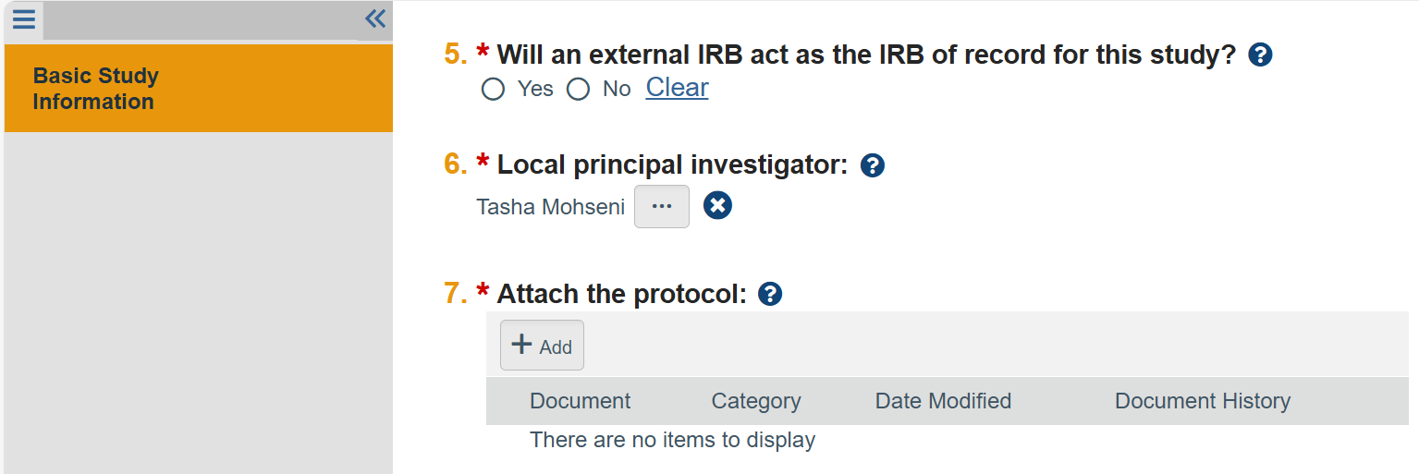

The consent form, recruitment materials, and supporting data collection documentation should be uploaded under “Local Site Documents” within their respective sections. This is to ensure the finalized version of these documents receive IRB watermarking upon approval:
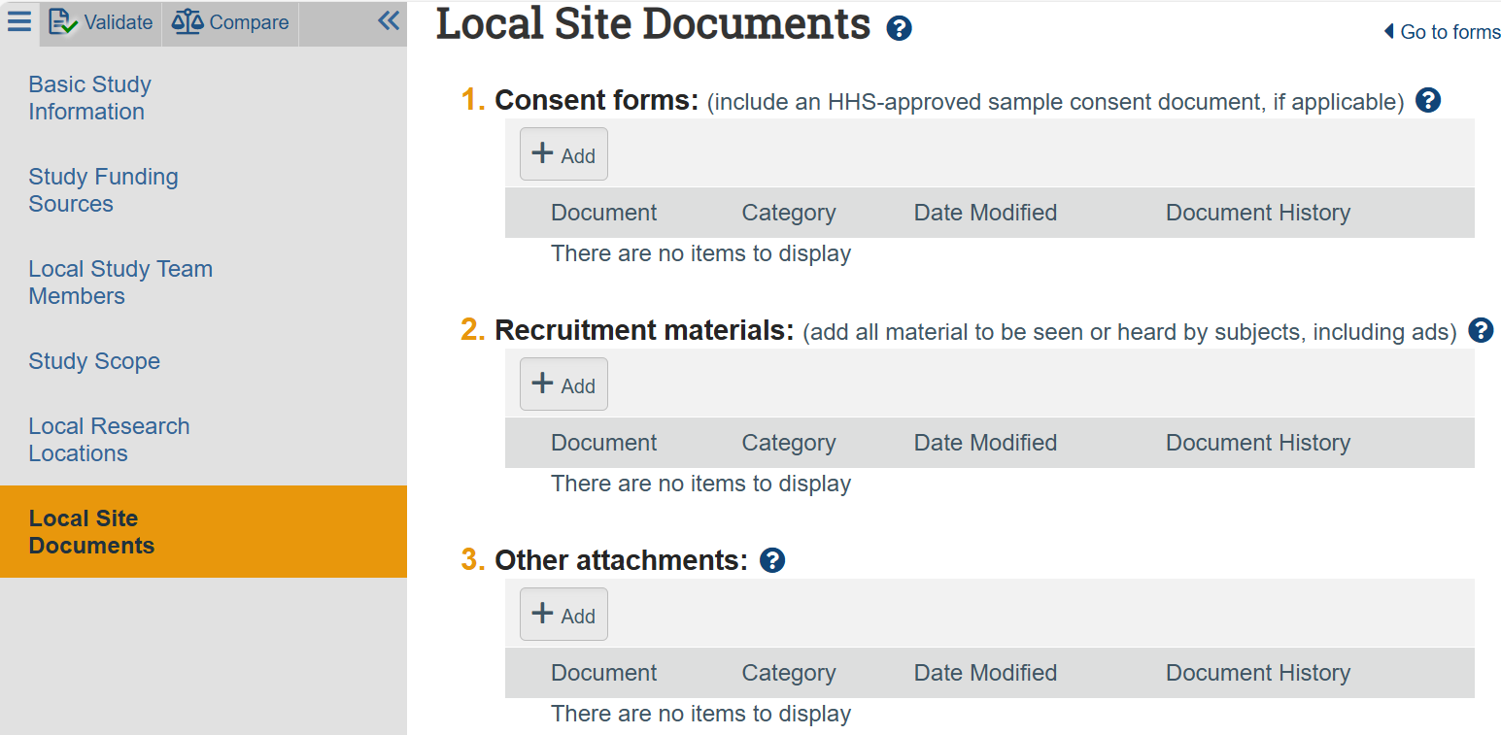

Why hasn’t my submission been reviewed in ERA yet?
If your submission is in the “Pre-Submission” state, then the submission has not entered IRB review. The PI on the submission must select “Submit” to have the submission reviewed by our team:
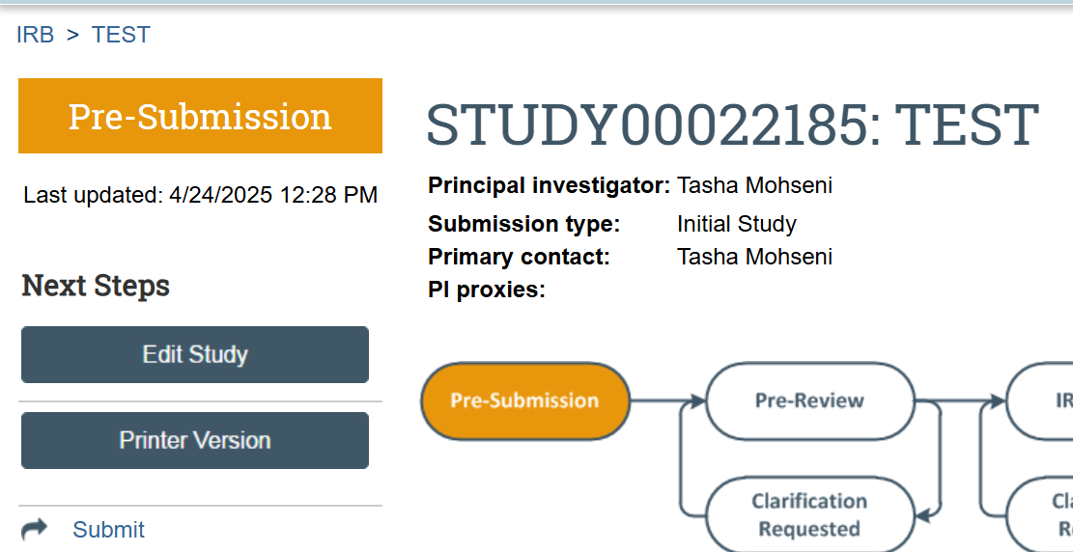

The submission state will change to “Pre-Review” (indicating that you have completed this step correctly):
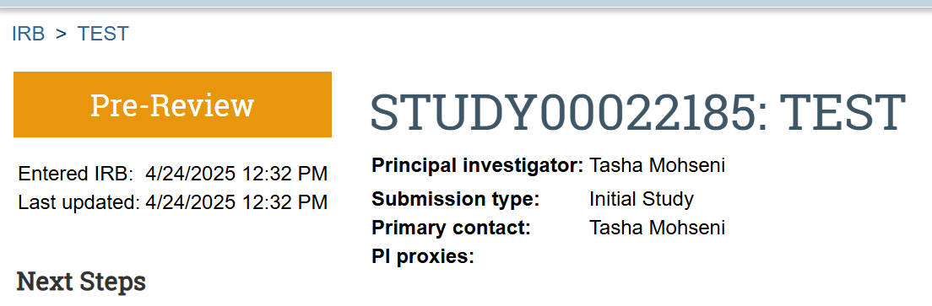

I left a comment on my submission, why hasn’t the IRB Coordinator responded?
When you select “Add Comment” within your submission, you want to ensure you check off “IRB Coordinator” under question #3 “Who should receive an e-mail notification?”:
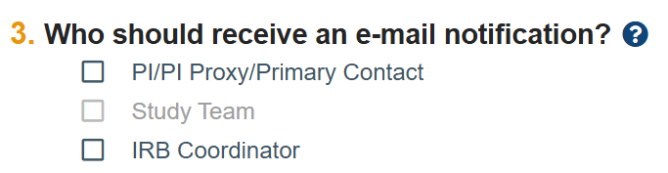

CITI Training

Who is required to complete human subjects research training and how can I access it?
All researchers and study team members engaged in human subjects research at ASU must complete training before being approved to work on a project (whether they are currently affiliated with ASU or as an external collaborator). We define “engagement” as being involved in any of the following activities:
- obtaining informed consent of a human subject for research
- data collection (unless they are collecting data as part of their normal job and are not involved with the research project beyond their ‘job’ for example, a hired phlebotomist or professional transcription service)
- data storage or access to study data
- data analysis (even if the data is de-identified)

ASU provides IRB training through a third-party called CITI Program, which can be accessed at the link here: CITI Program Training Website.

If you have questions about whether someone is engaged in research or about CITI, you may contact ASUIRB@asu.edu.

How do I know which CITI course I need to take?
Per the Training Information webpage, you can select the IRB CITI course that is most aligned with your research:
- IRB – Biomedical Research (Group 1) – complete this training if your research includes medical procedures, athletic procedures or studies of health outcomes.
- IRB – Social & Behavioral Research (Group 2) – complete this training if your research involves social and behavior techniques such as interviews or surveys.

Note that if your study meets the definition of a clinical trial, then study team members are also required to complete the Good Clinical Practices (GCP) course.

If you have questions about whether training requirements for your study, you may contact ASUIRB@asu.edu.

I completed a Responsible Conduct of Research (RCR) course. Does this count towards the IRB CITI course training requirement?
No, this does not count towards the IRB CITI course training requirement. RCR courses relate to a different compliance area. You can read more about RCR training here: Training Requirements

For any questions related to RCR training, you can contact RCR@asu.edu.

I am transferring from another university. Does ASU accept certificates from other institutions?
ASU may accept IRB training that was previously completed through another institution (either CITI training or an alternative). Please upload a copy of your certificate of completion with other study materials when you submit your IRB study. The IRB can let you know if this is appropriate.

How do I login to CITI and start my IRB training?
For instructions on how to do so, you can click on the Training Information page, scroll down to the bottom of the webpage, and review the appropriate process:
- Instructions to login into CITI with your ASURITE
- Instructions to login into CITI for ASU External Affiliates

I can’t find the IRB CITI training course from the instructions above. Once I add a CITI course, what do I do next?
On the “Select Curriculum” webpage, you would scroll down and select the “Human Subjects Research” category from the screenshot below:
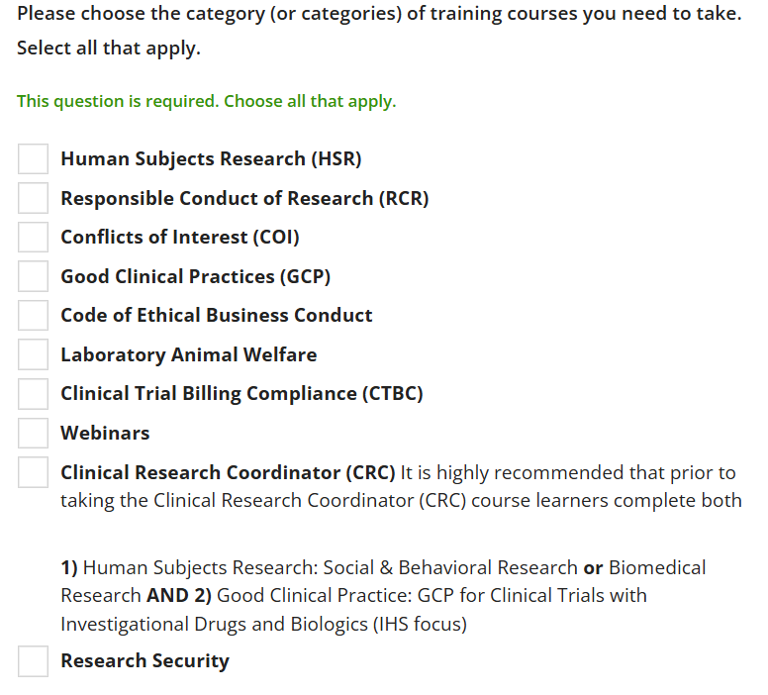

Does my CITI training expire?
- The IRB CITI program training is valid for 48 months. You are required to complete the refresher course once your training expires.
- The GCP CITI program training is valid for 36 months. You are required to complete the refresher course once your training expires.

How many times can I take the IRB CITI refresher course before I need to retake the main course?
- You can take the IRB CITI refresher course three times. After completing the refresher course for the third time, you will be required to retake the full IRB course to maintain your certification.
- You can take the CITI GCP refresher course one time. After completing the refresher course, you will be required to retake the full GCP course to maintain your certification.

I tried to take the IRB CITI refresher course, but it wasn’t available even though I still had another refresher attempt.
This issue can occur due to changes in the course renewal schedule. If the course’s renewal rate changes and you access your next module before that change takes effect, you may temporarily lose access to the refresher course. If you encounter this issue, we recommend waiting and checking back later, as the refresher course may become available again.

Application Process

My sponsor requires IRB approval before my grant can be accepted. What documentation can I provide since my study plans are not finalized yet?
Occasionally, a sponsor will require IRB approval or pending approval before a grant will be accepted:
- A 118 letter (named from Federal Regulation 45 CFR 46.118) is for just-in-time situations where the funding agency needs documentation from the IRB, but the IRB doesn’t have anything to review.
- It is notification that the IRB is aware of the study and that approval will be obtained once materials have been developed.
- The 118 letter doesn’t let you conduct any research with human subjects (actual approval is still required), but does let you develop the materials to conduct that research.

To request a 118 letter:
- Log into ERA IRB module: ERA Portal
- Create a new study.
- Fill out the basic IRB study information.
- Under “Attach a protocol" section, fill out/upload the JIT 118 letter template with your specific project information, available here:
- Under "Study Funding Sources", include: the funding source (typically the direct sponsor unless there is a primary/originating sponsor), Grants Office ID (FP000XXXXX), and the fully funded proposal.
- Finish the application and return to the main IRB submission page.
- Click "submit response".

What is the Wizard Tool and how do I know if my study is eligible?
ASU IRB has implemented a Wizard tool to streamline IRB review process for studies that fall under one or more exempt categories. ASU researchers can gather more information here: ASU IRB Exempt Wizard Tool.

For any questions related to this tool, please check out our Exempt Wizard FAQ.

My study is not eligible for the Wizard Tool. How does the ASU IRB review applications?
Submit your study directly to ERA. If you have questions about your study’s determination, you can contact ASUIRB@asu.edu for clarification.

ASU’s review process is designed to efficiently assess the risk of a study to human subjects. Studies involving higher risk undergo greater scrutiny while low risk studies can be reviewed and approved more quickly. Studies proposed with protected/vulnerable populations like prisoners, pregnant women, fetus involving risks to these populations can take longer to approve. Also, studies that are proposed with Tribes require cultural review in addition to IRB review.

In general, there are three review categories:
 | Expires | Requires Modifications | Requires Reporting of Adverse Events (RNIs) | Requires Yearly Continuing Review (CRs/MODCRs) or study closure
Exempt | No | *Some | Yes | No
Expedited | Yes | Yes | Yes | IRB makes the determination
Full Board | Yes | Yes | Yes | **Yes

* Changes to exempt studies do not need review unless change would make the study non-exempt, a change in the approved procedures, and/or changes to study team members. Contact ASUIRB@asu.edu to determine if a modification is required.

** Must be done by a convened full board. The board review schedule can be found here: Protocol Submission.

For additional details, you can review additional resources on this topic by clicking here: Review Process.

I would like to submit my study for IRB review. What materials do I need to prepare before submitting my application to ERA?
You can view details about this process here: Protocol Submission.

In general, the following items are required:
- Identification of an eligible PI; see PI Eligibility policy.
- Protocol template: fill out every section of the form according to the guidance provided within it. If a section does not apply, provide a brief explanation as to why. Every submission must include one of the two protocol templates, which can be found here: Forms.
- Recruitment materials: you must submit any recruitment materials to be used for review and approval. You may create your own or use one of the following templates as a guide: Forms.
- Consent form: almost every study will require a consent form to be developed and attached to the submission. Use the appropriate form for guidance. If your research involves minors, an assent, and parental permission form may be required. Medical release or data repository consent form templates are also available.
- Identification of study team and completed CITI training.
  - You can read more about CITI training within the FAQ or on the Training Information webpage.
- Fully funded proposal documentation (if your study is externally funded outside of ASU).
  - You will also need Grant Office ID (FP000XXXXX) and,
  - To notate the direct sponsor (or prime/originating sponsor) within the Study Funding Sources in ERA.
- Site permissions (if applicable): we prefer having the letter on the external organization’s letterhead that has all the contact information for the authorized signatory official. As far as content is concerned, you must include the following:
  - A statement that they are aware of ASU researchers conducting the project.
  - A few details about the purpose of the project, target participants and proposed data collection procedures, and any other resources that the site is willing to offer (such as conference room, staff etc.).
- Review of special circumstances (further discussed below)

As I am gathering my application materials, what are some examples of special circumstances I should consider?
Below are some examples of special circumstances that may be applicable to your study. If you have any questions, you may email ASUIRB@asu.edu.

To review the special considerations listed below in greater detail (as well as other examples), you can click here: Special Considerations.

Data Use Agreements (DUAs)
A Data Use Agreement (DUA) may be required whenever certain types of human subject data are being sent or received between ASU and an Outside Party. If there is a need to put a DUA into place per data provider’s request or a signature is needed on a current DUA, please reach out to industryagreements@asu.edu. DUAs typically have institutional terms and conditions; therefore, they should not be signed by an Investigator/student/post doc.

Research Subject Compensation
Arizona State University (ASU) is responsible for maintaining various levels of confidentiality with respect to information obtained from or about individuals participating in research.
- At the same time, ASU must comply with the record keeping requirements of the State of Arizona, sponsoring agencies, and the Internal Revenue Service.
- Consistent with FIN 421-05 ("Human Subject Payments"), payments to individuals participating in research studies must be recorded as a form of compensation.
- When considering payments to individuals participating in research studies, researchers are strongly advised to review the following policies:
  - FIN 421-05 ("Human Subject Payments")
  - FIN 401-03 ("Prohibited Transactions")

The study team should carefully and consult with their unit's business operations team during research study planning.

NOTE: Department Research Administrator and Business Officer staff are critical partners in assisting faculty members to determine an appropriate mechanism for research subject payments. Business office resources regarding research subject pay can be found here: Forms.

Collaborating with Other Institutions
When work involves researchers from multiple institutions under the purview of different IRBs, you may proceed one of two ways:
      - Have each IRB review the submission independently. Your initial submission should only include ASU researchers and describe the scope of the project as ASU will be involved. Other researchers can then be added via a modification as their IRBs review and approve their role in the project.
      - Have one IRB serve as the IRB of record. This means that one IRB gives up oversight of the research activity to another IRB via an affiliation agreement. These agreements are designed to reduce duplication and increase efficiency by designating a single IRB review when more than one site is involved in a research project. The research team will need to contact each IRB to confirm that they are willing to defer review to a single IRB of record before submitting. Institutional officials or their designee at each IRB will then sign an affiliation agreement that you will need to submit according to their policies and procedures. ASU will not enter into reliance agreements with agreements outside of the United States. Details on affiliation agreements can be found here: Special Considerations.

When another IRB is designated as the IRB of record, then the ASU IRB will rely on the review, approval and continuing oversight by the responsible IRB. After the external IRB has agreed to serve as the IRB of record, ASU will conduct a local context review. A local context review is required when ASU researcher(s) are engaged in human subjects research (through consenting, collecting data or analyzing data).

When submitting a local context review via ERA for review, ensure the following documents are included:
- External IRB Documents:
  - IRB approval letter
  - Approved IRB protocol application
  - All approved document (consent forms, recruitment scripts, data collection tools, etc.)
- Local context review form
- For any external collaborators:
  - A word document with a list of external study team members describing their roles
- If there are funds coming to ASU (Study Funding Sources):
  - Funding Source (XXX)
  - Grants Office ID (FP000XXXXX)
  - Attachments (fully funded proposal)
- IRB reliance agreement/Institutional Affiliation Agreement (which may be executed before ASU PI submits to the IRB or during the IRB review at ASU via email or SMART IRB portal)

I have all my materials ready to go. How do I submit my study through ERA?
To submit your study to ERA for IRB review:
- Log into ERA and click on the “IRB” tab
- On the lefthand side, select "Create" and select "Create New Study"
- Fill out the “Basic Study Information”:
  - If there are no external collaborators for your project, then you will indicate this is a single-site study with ASU as the IRB of record
  - If there are external collaborators for your project, indicate that this is a multi-site/collaborative study and indicate which institution is serving as the IRB of record.
  - Upload the protocol under the "Attach a protocol" question
- Under "Study Funding Sources", include (ONLY IF EXTERNAL FUNDS ARE COMING TO ASU):
  - Funding Source (Direct Sponsor – otherwise Prime/Originating Sponsor)
  - Grants Office ID (FP000XXXXX or AWD000XXXXX)
  - Attachments (fully funded proposal)
- Under “Local Study Team Members”, include any ASU Study Team Members and external collaborators
  - For external collaborators:
    - Proof of CITI training or equivalent human subjects protection training
    - Documentation from the external institution (either in the form of an email or the external IRB’s approval letter)
    - A word document detailing the collaborators’ role in the project and affiliation
  - For ASU Study Team Members not found in the first section needs to be added here to be manually added to the database. You can do this using the study team member’s written ASURITE ID. When the individual is added it will show ABOR as an affiliation.
- Under “Local Site Documents”, upload the consent form, recruitment materials, and supporting documentation to their respective sections.
- Click “Save”, then “Finish” within the IRB Smart Form
- You will be brought back to the study record’s main page and the submission will be in a “Pre-submission” state in an orange box on the lefthand side of the screen
- Under “Next Steps”, the PI on the IRB submission can press “Submit” (the study’s state will change from “Pre-submission” to “Pre-Review” indicating the submission has entered our queue and will be assigned to a member of the ORIA IRB Staff for review)

You can also review the video for guidance: How to Submit an Initial Study in ERA.

Study Modifications

How would I add or remove members from the study team?
To add or remove study team members:
- Login to ERA and navigate to the desired study
- On the lefthand side, under "Next Steps", select "Create MOD/CR“
- Select "Create MOD“
- Select "Study Team Member Information“
- Make necessary additions and/or deletions to the study team under “Local Study Team Members"
  - For external collaborators:
    - Proof of CITI training or equivalent human subjects protection training
    - Documentation from the external institution (either in the form of an email or the external IRB’s approval letter)
    - A word document detailing the collaborators’ role in the project and affiliation
  - For ASU Study Team Members not found in the first section needs to be added here to be manually added to the database. You can do this using the study team member’s written ASURITE ID. When the individual is added it will show ABOR as an affiliation.
- Click “Save”, then “Finish” within the IRB Smart Form
- You will be brought back to the study record’s main page and the submission will be in a “Pre-submission” state in an orange box on the lefthand side of the screen
- Under “Next Steps”, the PI on the IRB submission can press “Submit” (the study’s state will change from “Pre-submission” to “Pre-Review” indicating the submission has entered our queue and will be assigned to a member of the ORIA IRB Staff for review)

How would I make changes to my approved IRB protocol?
Whether you are adding another method of data collection, adding or removing survey questions, uploading translated materials, or making any other changes to your approved IRB protocol, you may follow the process below:
- Login to ERA and navigate to the desired study
- Select "Create MOD/CR“
- Select "Create MOD“
- Select “Other Parts of Study“
- Upload revised IRB protocol and supporting documentation to the designated sections in ERA to receive the IRB watermarking upon approval
- Click “Save”, then “Finish” within the IRB Smart Form
- You will be brought back to the study record’s main page and the submission will be in a “Pre-submission” state in an orange box on the lefthand side of the screen
- Under “Next Steps”, the PI on the IRB submission can press “Submit” (the study’s state will change from “Pre-submission” to “Pre-Review” indicating the submission has entered our queue and will be assigned to a member of the ORIA IRB Staff for review)

I received a grant for my IRB study. How do I add the funding to my approved IRB study?
To add external funding (i.e., funds OUTSIDE of ASU) to your study:
- Login to ERA and navigate to the desired study
- Select "Create MOD/CR“
- Select "Create MOD“
- Select “Other Parts of Study“
- Update the Study Funding Sources to include:
  - Funding Source (Direct Sponsor – otherwise Prime/Originating Sponsor)
  - Grants Office ID (FP000XXXXX or AWD000XXXXX)
  - Attachments (fully funded proposal)
- Click “Save”, then “Finish” within the IRB Smart Form
- You will be brought back to the study record’s main page and the submission will be in a “Pre-submission” state in an orange box on the lefthand side of the screen
- Under “Next Steps”, the PI on the IRB submission can press “Submit” (the study’s state will change from “Pre-submission” to “Pre-Review” indicating the submission has entered our queue and will be assigned to a member of the ORIA IRB Staff for review)

I would like to change the PI of my approved IRB study. How do I transfer the study over to the new PI?
To change the PI on your approved IRB study:
- Login to ERA and navigate to the desired study
- Select "Create MOD/CR“
- Select "Create MOD“
- Select “Other Parts of Study“
- Upload a copy of the email correspondence from the new PI stating that they will be the new PI on the IRB submission under ERA - Local Site Documents - Other Attachments
- Within the IRB Smart Form under "Basic Study Information" change the local PI to the new PI
- Upload revised protocol and supporting materials to reflect the new PI
- Click “Save”, then “Finish” within the IRB Smart Form
- You will be brought back to the study record’s main page and the submission will be in a “Pre-submission” state in an orange box on the lefthand side of the screen
- Under “Next Steps”, the PI on the IRB submission can press “Submit” (the study’s state will change from “Pre-submission” to “Pre-Review” indicating the submission has entered our queue and will be assigned to a member of the ORIA IRB Staff for review)

Reportable New Information

What is Reportable New Information (RNI)?
Reportable New Information (RNI) is classified as any adverse events, unanticipated problems involving risk, and/or non-compliance. You can read more about RNIs here: Reportable Events.

When must adverse events be reported?
Any serious events must be reported within 24 hours (which include, but are not limited to):
- Death
- Life-threatening event
- In-patient hospitalization
- Prolongation of existing hospitalization
- A persistent or significant disability/incapacity

Non-serious adverse events must be reported within 5 business days.

You can read more about reportable events under “What must be reported” on the following webpage: Reportable Events.

How do I submit a RNI for review?
To submit these reportable events in ERA:
- Log into ERA and click on the “IRB” tab
- On the lefthand side, select "Create" and select "Reportable New Information"
- Fill out the form following the instructions:
  - The "RNI short title" should reflect the name of the specific event that occurred
  - For "Related studies and modifications", the researcher must list the submission ID related to the event as RNIs are not currently linked to submissions in ERA
- Click “Save”, then “Finish” within the IRB Smart Form
- You will be brought back to the study record’s main page and the submission will be in a “Pre-submission” state in an orange box on the lefthand side of the screen
- Under “Next Steps”, the PI on the IRB submission can press “Submit” (the study’s state will change from “Pre-submission” to “Pre-Review” indicating the submission has entered our queue and will be assigned to a member of the ORIA IRB Staff for review)

Continuing Reviews

What is a Continuing Review?
Studies approved as Full Board require a yearly Continuing Review:
- The Continuing Review application must be submitted at least 2 weeks before an IRB meeting date.
- If a Continuing Review requiring Full Board review is not received in time, work on the project will need to cease and it will need to be reviewed at the next meeting.

Studies approved as Expedited also require a Continuing Review. Continuing Reviews can be required anywhere from 1-5 years after the study’s initial approval.

You will receive a notification 3 months prior to the deadline for a Continuing Review. It is strongly recommended to allow the IRB approximately a week to review to avoid lapsed IRB approval.

If an investigator fails to submit a continuing review (i.e., the study lapses) or the IRB does not approve a continuation before the date of expiration, all research activities must stop, including:
- Subject recruitment or enrollment.
- Collection of data/information.
- All research-related interventions or interactions with currently enrolled subjects.
- Data analyses involving subject-identifiable data.
The Continuing Review requires answers to several questions and an updated progress report.

Is there a template for the progress report?
There is currently not a template for the progress report. However, the report should include:
- The number of participants.
- A summary of any:
  - Changes to the research approved by the IRB since the IRB’s initial review or the last continuing review.
  - Unanticipated events.
  - Subjects who withdrew from the project and the reasons for withdrawal, if known.
  - Complaints about the research from subjects or others since the last IRB review.
- Any new and relevant information, published or unpublished, since the last IRB review, especially information about risks

How to I submit a Continuing Review in ERA?
To submit a Continuing Review:
- Login to ERA and navigate to the desired study.
- Select "Create MOD/CR“.
- Select “Continuing Review”.
- Fill out the form following the instructions:
  - For questions #1-3, if this is your first Continuing Review, then all enrollment totals will be the same number. For subsequent reviews, question #2 will reflect the total number participants enrolled since the last approval period (i.e., the last Continuing Review).
    - In addition (for subsequent reviews), questions #1 and #3 will have the same grand enrollment total (for single-site studies).
  - For question #4, research milestone #4 should NOT be checked off unless you are aiming to close the study.
    - If data collection will continue, no boxes should be checked.
    - If study activities are limited to data analyses, then research milestones #1, #2, #3, and #5 should be checked ONLY to signify this.
  - For question #5, any items unchecked need to be explained in the progress report
  - For question #6, the uploaded progress report including the information described above.
- Click “Save”, then “Finish” within the IRB Smart Form.
- You will be brought back to the study record’s main page and the submission will be in a “Pre-submission” state in an orange box on the lefthand side of the screen.
- Under “Next Steps”, the PI on the IRB submission can press “Submit” (the study’s state will change from “Pre-submission” to “Pre-Review” indicating the submission has entered our queue and will be assigned to a member of the ORIA IRB Staff for review).

Study Closure

Our team has completed all human subjects research activities. We are now in the process of publishing our results. Do I need to submit a Continuing Review?
If all human subjects research activities are complete, including data analysis (even if the data is de-identified), then you may close the study.

The activities for this project are complete. How do I close my study in ERA?
To close your study:
- Login to ERA and navigate to the desired study.
- Select "Create MOD/CR.
- Select “Continuing Review”.
- Fill out the form following the instructions:
  - Questions #1 and #3 will have the same grand enrollment total (for single-site studies).
  - Question #2 will reflect the total number participants enrolled since the last approval period (i.e., the last Continuing Review).
  - Question #4, research milestones #1-4 should ONLY be checked.
  - Question #5, you must check the box to acknowledge the study will be closed.
  - Question #6, any items unchecked need to be explained in the summary of findings.
  - Question #7, the summary of findings (typically 1-4 paragraphs in length).
- Click “Save”, then “Finish” within the IRB Smart Form.
- You will be brought back to the study record’s main page and the submission will be in a “Pre-submission” state in an orange box on the lefthand side of the screen.
- Under “Next Steps”, the PI on the IRB submission can press “Submit” (the study’s state will change from “Pre-submission” to “Pre-Review” indicating the submission has entered our queue and will be assigned to a member of the ORIA IRB Staff for review).

If my study is closed, am I able to reopen my study for additional project scope?
Though you are not able to reopen a study that has been closed, you can create a new submission by selecting “Copy Submission” within the study record:
