**Arizona State University**

**Institutional Animal Care and Use Committee**

**STANDARD INSTITUTIONAL GUIDELINE**

**INTRANASAL AND ORAL ADMINISTRATION IN RODENTS**

**Purpose**

Intranasal and oral administration is a less invasive and more clinically relevant means of delivering various treatments, antigens, and vaccines.

**Delivery of Treatment, Antigen, or Vaccine**

All procedures should be done using personal protective equipment and a biosafety cabinet if required for the room housing the animals or the BSL level of the agent.

***Intranasal – a.k.a. delivery of material into the nostrils***

**Mouse**

1. The mouse is restrained by holding it by the scruff in dorsal recumbency.
2. 5-10 microliters (µL) of material is delivered by the individual restraining the mouse or a second individual into each nostril using a mechanical pipette. The mouse is carefully monitored for signs of distress (excessive struggling, mucus membrane color changes, ventilatory changes) while the procedure is being performed and between nostril injections.
3. If the animal shows any signs of distress, it is released from restraint and monitored. The veterinary team should be called if the animal does not immediately return to a normal state.
4. The mouse is then returned to its cage and observed for any signs of distress that are immediately apparent.
5. Delivery of material is conducted at intervals and durations as described in the IACUC-approved protocol.

**Rat**

1. The rat is restrained by wrapping it in a towel and holding the temporomandibular joint gently to control head movement.
2. 10-20 microliters (µL) of material is delivered by the individual restraining the rat or a second individual into each nostril using a mechanical pipette. The animal is carefully monitored for signs of distress (excessive struggling, mucus membrane color changes, ventilatory changes) while the procedure is being performed and between nostril injections.
3. If the animal shows any signs of distress, it is released from restraint and monitored. The veterinary team should be called if the animal does not immediately return to a normal state.
4. The rat is then returned to its cage and observed for any signs of distress that are immediately apparent.
5. Delivery of material is conducted at intervals and durations as described in the IACUC-approved protocol.

***Oral* *Gavage*** ***– a.k.a. delivery of material directly into the stomach***

**Equipment**

Oral gavage needles come in plastic and metal varieties. The plastic needles are recommended due to a reduction in potential adverse events because the metal needles have an increased chance of perforating the esophagus during the procedure.

**Mouse**

1. An appropriately sized gavage needle is attached to 1ml syringe. Needle gauge size for a mouse should be 20-22g with the length depending on the size of the mouse. To determine the proper needle length, place the ball end of the needle at the base of the rib cage (Figure a). For an average-sized adult mouse, the hub of a 1.5-inch gavage needle would line up with the corner of the mouse’s mouth. While measuring, if the hub of the gavage needle extends past the mouth when the ball end is at the lower limit of the rib cage, place a Sharpie mark on the needle where the corner of the mouth is. This mark will indicate the stopping point when inserting the gavage needle down the esophagus.
2. The mouse is restrained in a vertical (i.e., head up) position by holding the mouse by the scruff. It is important that the mouse’s head and neck are extended so that they are straight in line with the spine (Figures b, c).
3. The gavage needle is gently and slowly passed down the esophagus until the tip of the gavage needle hub or the mark on the needle reaches the corner of the mouse’s mouth. If resistance is noted while inserting the gavage needle, it should be retracted and repositioned. Delivery volume should not exceed 200ul.
4. Once the needle is properly positioned, the material is slowly administered while the mouse is monitored for signs of distress (as described above) or the emergence of fluid from the nostrils. Upon completion of delivery of the material, the needle is carefully removed and the mouse returned to its cage.
5. Delivery of material is conducted at intervals and durations as described in the IACUC protocol.

|  |  |  |
| --- | --- | --- |
| Weight range (g) | Needle Gauge | Needle Length (inches) |
| 15-20 | 22 | 1-1.5 |
| 20-25 | 22-20 | 1-1.5 |
| 25-30 | 20 | 1.5-2 |
| 30-35 | 20-18 | 2 |

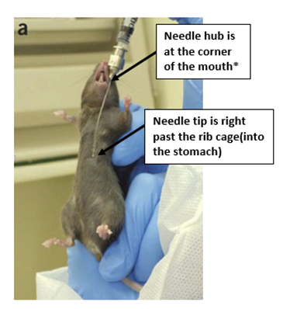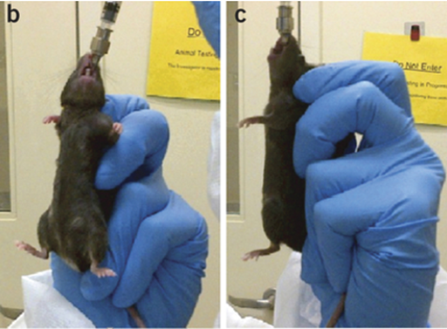

**\* The needle size here is 20-22g x 1.5 inch**

**Rat**

1. An appropriately sized gavage needle is attached to 1-3ml syringe. Needle gauge size for a rat should be 15-18g with the length depending on the size of the rat. A proper measurement is made by measuring from the corner of the mouth to just past the rib cage (Figure a). For an average-sized adult rat, the hub of a 3-inch gavage needle should line up with the corner of the mouse’s mouth. While measuring, if the hub of the gavage needle extends past the mouth when the ball end is at the lower limit of the rib cage, place a Sharpie mark on the needle where the corner of the mouth is. This mark will indicate the stopping point when inserting the gavage needle down the esophagus.
2. The rat is restrained by wrapping it in a towel and gently holding the temporomandibular joint to control head movement.
3. The gavage needle is carefully and slowly passed down the esophagus until the hub or mark on the needle reaches the corner of the rat’s mouth. If resistance is noted while being inserted, the gavage needle is retracted and repositioned. Delivery volume should not exceed 2ml.
4. Once the needle is properly positioned, the material is slowly administered while the rat is monitored for signs of distress (as described above) or the emergence of fluid from the nostrils. The needle can then be carefully removed and the rat returned to its cage.
5. Delivery of material is conducted at intervals and durations as described in the IACUC protocol.

|  |  |  |
| --- | --- | --- |
| Weight range (g) | Needle Gauge | Needle Length (inches) |
| 50-75 | 20 | 1-1.5 |
| 75-100 | 18 | 1-1.5 |
| 100-200 | 18 | 2-3 |
| 200-300 | 16 | 3-4 |

***Oral* *Administration – a.k.a. delivery of material into the mouth***

**Mouse**

1. The mouse is restrained in a vertical (i.e., head up) position by holding the mouse by the scruff.
2. 5-25µl of material is slowly dripped into the mouse’s mouth using a mechanical pipette, allowing time for the animal to swallow each drop. After delivery, the animal should be held for approximately 20 additional seconds to ensure that the material is consumed.
   1. The pipette tip should not enter the mouth to avoid potential damage.
3. Delivery of material is conducted at intervals and durations as described in the IACUC protocol.

**Rat**

1. The rat is restrained by wrapping it in a towel and gently holding the temporomandibular joint to control head movement.
2. 5-100µl is slowly dripped into the rat’s mouth using a mechanical pipette, allowing time for the animal to swallow each drop. After delivery, the animal should be held for approximately 20 additional seconds to ensure that the material is consumed.
   1. The pipette tip should not enter the mouth to avoid potential damage.
3. Delivery of material is conducted at intervals and durations as described in the IACUC protocol.